**TRAFFIC LIGHT Part 1**

Objective:

Create a traffic light signal using 3 LED's (any colour of your choice) such that each of them turns on after every 1 sec respectively.

TinkerCad Circuit Link:

<https://www.tinkercad.com/things/7GSIo6cMS22-b-traffic-light-simple/editel?sharecode=JxMACkz9ET-y1idE7eDhJuQGFs9pZL5lCI5R63veAsg>

Circuit Diagram:

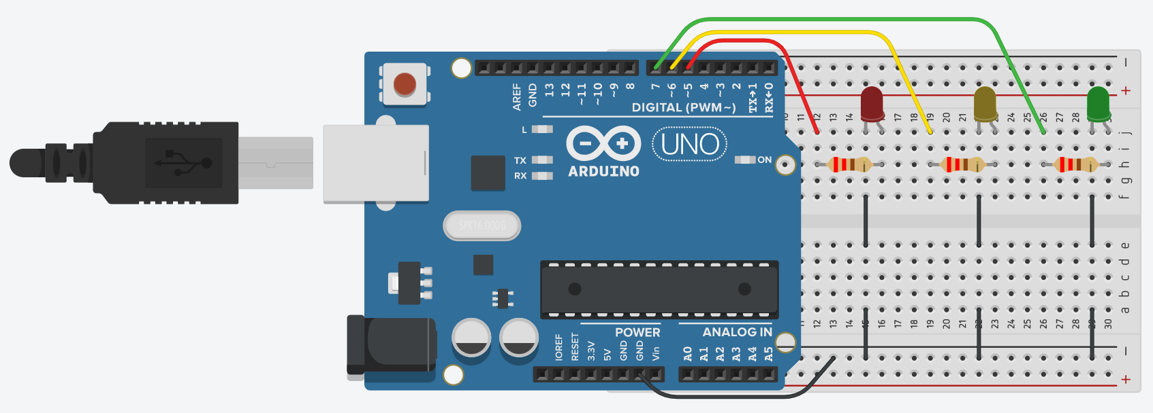

Code:

